JAVA Abstraction

Abstract class
- Abstract class হলো এমন এক ধরনের class, যেটা দিয়ে সরাসরি object তৈরি করা যায় না।
- এর মূল উদ্দেশ্য হলো abstraction (অপ্রয়োজনীয় অংশ লুকানো) আর base class হিসেবে কাজ করা।
- A class that is declared with the abstract keyword is known as an abstract class. It can have abstract and non-abstract methods (methods with a body). An abstract class is a class that cannot be instantiated directly. It serves as a blueprint for other classes.
- An abstract class in Java acts as a partially implemented class that itself cannot be instantiated. It exists only for subclassing purposes, and provides a template for its subcategories to follow. Abstract classes can have implementations with abstract methods. Abstract methods are declared to have no body, leaving their implementation to subclasses.
Abstract class-এর মধ্যে থাকতে পারে:
- Abstract methods (যার body থাকে না, শুধু declaration থাকে)।
- Normal methods (যার body থাকে)।
- Variables, constructors, static methods ও থাকতে পারে।
Definition of Abstract Class: “An abstract class is a class in Java that is declared using the abstract keyword, which may include abstract methods and concrete methods, and serves as a blueprint for subclasses. It cannot be instantiated directly but must be extended by other classes that provide implementations for its abstract methods.”
Definition of Abstract Method: A method which is declared as abstract and does not have implementation is known as an abstract method.
Abstract Class = এমন একটি ক্লাস যেখানে abstract method থাকতে পারে, তবে সব মেথড abstract হতে হবে—এমন কোনো বাধ্যবাধকতা নেই।
মানে, Abstract Class-এ আপনি চাইলে
- abstract method (body ছাড়া)
- আবার normal (concrete) method (body সহ)
দুটোই রাখতে পারেন।
abstract class normal method লিখতে পারে।
শুধু abstract method থাকলে body দিতে হবে না।
Syntax Abstract Class:
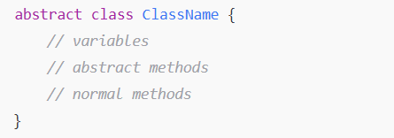
- Abstract method হলো method যার কোনো body নেই, শুধু declaration আছে।
- Subclass অবশ্যই এই method implement করতে হবে।

Example:
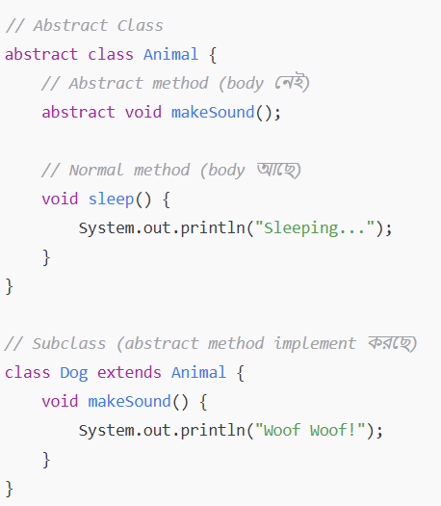
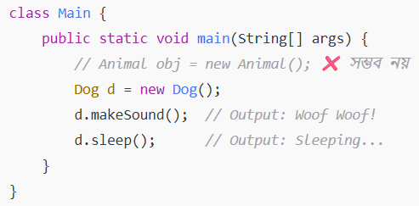

- Animal obj = new Animal(); ❌ সম্ভব নয় এর মানে হলো — abstract class দিয়ে object বানানো যায় না।
কারণ:
- Abstract class অসম্পূর্ণ থাকে
  - Abstract class-এর মধ্যে abstract method থাকে, যেটার কোনো body থাকে না (মানে কাজের কোড লেখা থাকে না)।
  - যদি জাভা abstract class-এর object বানাতে দিত, তাহলে ওই object দিয়ে কেউ যদি ওই method call করতো, তখন জাভা বুঝতেই পারত না কী কাজ করবে — কারণ method-এর body-ই নেই।
  - তাই জাভা সরাসরি object বানাতে দেয় না।
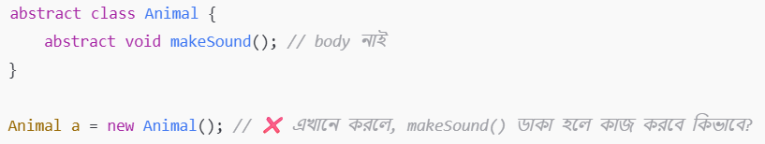
- Abstract class-এর উদ্দেশ্য হলো "template/base class" দেওয়া
  - Abstract class দিয়ে আমরা একটা common design বানাই।
  - Subclass গুলো সেটা inherit করে নিজের মতো implement করে।
  - তাই object সবসময় subclass দিয়ে বানাতে হয়, abstract class দিয়ে নয়।

- Abstraction is a process of hiding the implementation details and showing only functionality to the user.
Another way, it shows only essential things to the user and hides the internal details, for example, sending SMS where we type the text and send the message. We do not know the internal processing about the message delivery.
Abstraction lets you focus on what the object does instead of how it does it.

Abstract Class-এর বৈশিষ্ট্য
- Object তৈরি করা যায় না।
- Abstract method থাকতে পারে, নাও থাকতে পারে।
- Subclass কে অবশ্যই abstract method গুলো implement করতে হবে।
- Normal method থাকলে subclass সেগুলোকে চাইলে override করতে পারে, নাহলে default ভাবেও ব্যবহার করতে পারে।
- Abstract class-এ constructor থাকতে পারে (object বানানোর জন্য না, কিন্তু initialization-এর জন্য)।
🔑 Key Features of Abstract Class
- Abstract methods থাকতে পারে।
- Concrete (normal) methods থাকতে পারে।
- Constructor থাকতে পারে (subclass object তৈরি হলে constructor চালু হয়)।
- Static methods থাকতে পারে।
- Final methods থাকতে পারে → subclass override করতে পারবে না।
- Instantiate করা যায় না → subclass দিয়ে object বানাতে হয়।

Note: If there is an abstract method in a class, that class must be abstract.
- class Bike12{
- abstract void run();
- }
Output:
compile time error

Note: If we are extending an abstract class that has an abstract method, we must either provide the implementation of the method or make this class abstract.

Interface
Abstraction (Abstract Class)
Definition:
Abstract class হলো এমন একটি class যেটা সম্পূর্ণভাবে object তৈরি করতে পারে না, কিন্তু অন্য class গুলোকে base (parent) হিসেবে কাজ দেয়।
এতে abstract method (যার body নেই) এবং non-abstract method (যার body আছে) — দুটোই থাকতে পারে।
🧩 বৈশিষ্ট্য:
- abstract keyword দিয়ে declare করা হয়।
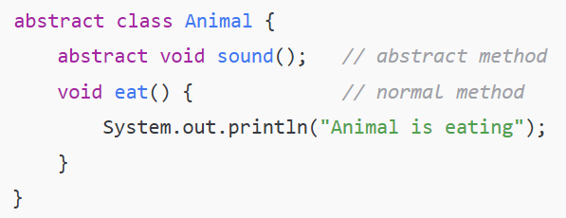
- Abstract class এ constructor, instance variable, normal methods থাকতে পারে।
- একাধিক class কে inherit করা যায় না (single inheritance)।
- “is-a” relationship বোঝাতে ব্যবহার হয়।
- Abstract class এর মাধ্যমে partial abstraction করা যায় (মানে সব method abstract না হলেও চলে)।

Interface
Definition:
Interface হলো pure abstraction — অর্থাৎ, এখানে শুধু method declaration থাকে, body থাকে না (Java 8 এর আগে)।
এখন (Java 8+) interface এ default এবং static method body সহ রাখা যায়।
🧩 বৈশিষ্ট্য:
- interface keyword দিয়ে declare করা হয়।
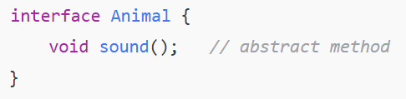
- সব method ডিফল্টভাবে public এবং abstract হয়।
- Variable গুলো public static final (মানে constant)।
- Class একাধিক interface implement করতে পারে → multiple inheritance সম্ভব।
- Interface ব্যবহার করা হয় “contract” বা “capability” define করতে।
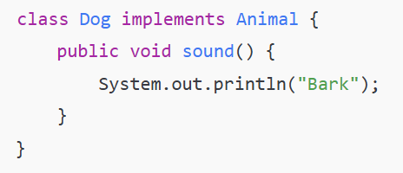

📊 Comparison Table
বিষয় | Abstract Class | Interface
Keyword | abstract | interface
Method Type | abstract + non-abstract | abstract (default & static allowed)
Variables | instance variable থাকতে পারে | শুধু public static final (constant)
Constructor | থাকতে পারে | থাকে না
Inheritance | একটিমাত্র class extend করা যায় | একাধিক interface implement করা যায়
Abstraction Level | Partial | Full (pure abstraction)
Usage | Common base behavior define করা | Common capability বা rule define করা

Interface হলো Java-তে একটি blueprint (খসড়া) যার মধ্যে শুধু method-এর নাম (signature) লেখা থাকে, কিন্তু method-এর ভিতরে কাজ (implementation) লেখা থাকে না।
অন্য কোনো class যখন ওই interface implement করে, তখন সেই class-কে interface-এর সব method-এর কাজ লিখতে হয়।
An interface in Java is a blueprint of a class. It has static constants and abstract methods.
The interface in Java is a mechanism to achieve abstraction. There can be only abstract methods in the Java interface, not a method body. It is used to achieve abstraction and multiple inheritance in Java.
In other words, we can say that interfaces can have abstract methods and variables. It cannot have a method body.
- Java Interface also represents the IS-A relationship.
- It cannot be instantiated just like the abstract class.
- Since Java 8, we can have default and static methods in an interface.
- Since Java 9, we can have private methods in an interface.

🔹 কেন দরকার?
- Interface ব্যবহার করলে multiple inheritance করা যায় (Java-তে class দিয়ে multiple inheritance করা যায় না)।
- এটি কোডকে flexible এবং loose coupling করে।
- Teamwork-এ interface খুব কাজে লাগে — একদল developer interface define করে, আরেক দল সেটার implementation লিখে।
Syntax:
- interface Animal {
- void eat();
- void sleep();
- }
এখানে Animal হলো একটি interface।
- এর ভেতরে শুধু method declaration আছে।
- কোনো body নেই ( {} এর মধ্যে কোড লেখা হয়নি)।
Any class implementing the Animal interface must provide concrete implementations for these methods.

- class Dog implements Animal {
- public void eat() {
- System.out.println("Dog is eating...");
- }

- public void sleep() {
- System.out.println("Dog is sleeping...");
- }
- }

- public class Main {
- public static void main(String[] args) {
- Animal a = new Dog();
- a.eat();
- a.sleep();
- }
- }

Output:
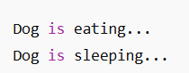

এখানে Dog class Animal interface implement করেছে।
তাই Dog class-কে eat() আর sleep() method-এর কাজ লিখতেই হবে।

🔑 Note:
- Interface-এর ভেতরের সব method public abstract হয় (by default)।
- Variable লিখলে সেটা public static final হয় (মানে constant)।
- এক class চাইলে একসাথে একাধিক interface implement করতে পারে।
The Java compiler adds the public and abstract keywords before the interface method. Moreover, it adds public, static and final keywords before data members.
An interface is declared by using the interface keyword. It provides total abstraction; it means all the methods in an interface are declared with an empty body, and all the fields are public, static and final by default. A class that implements an interface must implement all the methods declared in the interface.
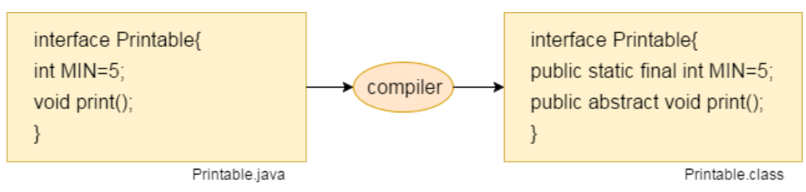

Relationship Between Classes and Interfaces:
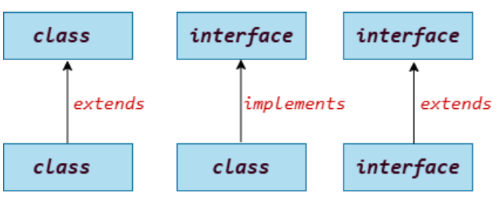
An interface is defined by someone else, but different implementation providers provide its implementation. Moreover, it is used by someone else. The implementation part is hidden from the user who uses the interface. ---means--
- Interface define করে একজন → সে শুধু বলে দেয় “এই কাজগুলো করতে হবে” (method এর নাম দিয়ে)।
- Implementation করে অন্যরা → ভিন্ন ভিন্ন class আলাদা আলাদা ভাবে সেই কাজের কোড লিখে।
- Use করে আরেকজন → সে শুধু interface-এর reference ব্যবহার করে method call করে, ভেতরে কীভাবে কাজ হচ্ছে সেটা জানার দরকার নেই।

Multiple Inheritance in Java by Interface:
If a class implements multiple interfaces, or an interface extends multiple interfaces, it is known as multiple inheritance.
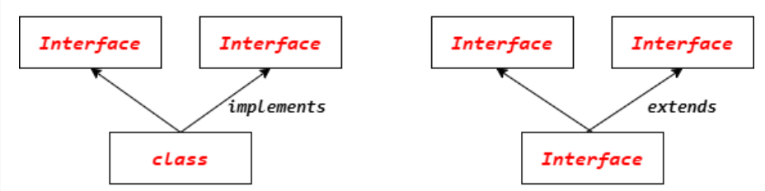

Default Method in Interface:
Since Java 8, we can have method body in interface. But we need to make it default method.
interface Drawable {
void draw();

default void msg() {
System.out.println("default method");
}
}

class Rectangle implements Drawable {
public void draw() {
System.out.println("drawing rectangle");
}
}

public class Main {
public static void main(String args[]) {
Drawable d = new Rectangle();
d.draw();
d.msg();
}
}

Output:
drawing rectangle
default method

Static Method in Interface:
interface Drawable {
void draw();
static int cube(int x) {
return x * x * x;
}
}
class Rectangle implements Drawable {
public void draw() {
System.out.println("drawing rectangle");
}
}

class Main {
public static void main(String args[]) {
Drawable d = new Rectangle();
d.draw();
System.out.println(Drawable.cube(3));
}
}

marker or tagged interface:
An interface that has no members is known as a marker or tagged interface. They are used to provide some essential information to the JVM so that the JVM may perform some useful operations.
- //How Serializable interface is written?
- public interface Serializable{
- }

Nested Interface:
An interface can have another interface, which is known as a nested interface.
- interface printable{
- void print();
- interface MessagePrintable{
- void msg();
- }
- }

Differences Between Abstract Class and Interface: (Again)
Features | Abstract Class | Interface
Definition | A class that cannot be instantiated and may contain abstract and concrete methods. | A contract specifying methods that must be implemented by a class.
Usage | It is used when we need shared functionality among related classes. | It is used when we need to enforce a common protocol or contract across classes.
Declaration | The abstract keyword is used to declare an abstract class. | The interface keyword is used to declare an interface.
Keyword | An abstract class can be extended using the keyword "extends". | An interface can be implemented using the keyword "implements".
Methods | Abstract class can have abstract and non-abstract methods. | An interface can have only abstract methods. Since Java 8, it can have default and static methods also.
Inheritance | Abstract class does not support multiple inheritance. | Interface supports multiple inheritance.
Constructors | It can have constructors to initialize objects. | It does not have constructors because interfaces cannot be instantiated.
Fields and Variables | Abstract class can have final, non-final, static and non-static variables. | Interface has only static and final variables.
Implementation | An abstract class can provide the implementation of the interface. | The interface cannot provide the implementation of an abstract class.
Inheritance | An abstract class can extend another Java class and implement multiple Java interfaces. | An interface can extend another Java interface only.
Members | A Java abstract class can have class members like private, protected, etc. | Members of a Java interface are public by default.
Example | public abstract class Shape{  public abstract void draw();  } | public interface Drawable{  void draw();  }

Difference between Abstract Class and Interface
Abstract classes provide partial abstraction (0-100%), while interfaces provide full abstraction (100%).
🔹 Abstract Class → Partial Abstraction (0–100%)
- Abstract class-এ abstract method (body ছাড়া) + concrete method (body সহ) দুটোই থাকতে পারে।
- তাই, কতটা abstraction হবে সেটা ডেভেলপার ঠিক করে → 0%, 50%, 100% ইত্যাদি হতে পারে।
🔹 Interface → Full Abstraction (100%)
- Interface-এ (Java 7 পর্যন্ত) সবগুলো method abstract।
- মানে, কোনো implementation নেই → শুধু contract থাকে।
- তাই এটা দেয় 100% abstraction।

Abstract Class Vs. Interface:
Simply, the abstract class achieves partial abstraction (0 to 100%), whereas the interface achieves full abstraction (100%).
Abstract Class | Interface
Abstract classes can have abstract and non-abstract methods. | An interface can have only abstract methods. Since Java 8, it can have default and static methods also.
Abstract class does not support multiple inheritance. | Interface supports multiple inheritance.
Abstract class can have final, non-final, static and non-static variables. | An interface has only static and final variables.
Abstract class can provide the implementation of the interface. | An interface cannot provide the implementation of an abstract class.
The abstract keyword is used to declare an abstract class. | The interface keyword is used to declare an interface.
An abstract class can extend another Java class and implement multiple Java interfaces. | An interface can extend another Java interface only.
An abstract class can be extended using the keyword "extends". | An interface can be implemented using the keyword "implements".
A Java abstract class can have class members like private, protected, etc. | Members of a Java interface are public by default.
Example:  public abstract class Shape{  public abstract void draw();  } | Example:  public interface Drawable{  void draw();  }

Example of Abstract Class and Interface:
//Creating an interface that has four methods
interface A {
void a(); //by default, public and abstract
void b();
void c();
void d();
}
//Creating an abstract class that provides the implementation of one method of A
// interface
abstract class B implements A {
public void c() {
System.out.println("I am C");
}
}
//Creating subclass of the abstract class, now we need to provide the implementation
// of the rest of the methods
class C extends B {
public void a() {
System.out.println("I am a");
}
public void b() {
System.out.println("I am b");
}
public void d() {
System.out.println("I am d");
}
}
// Creating a Main class that calls the methods of an interface
public class Main {
public static void main(String args[]) {
A a = new C();
a.a();
a.b();
a.c();
a.d();
}
}

